
Dashboard Design

Date | 1 November 2026
Team ID
Project Name | EV Market Performance & Insights Platform
Maximum Marks | 5 Marks

Creating an effective dashboard involves thoughtful design to ensure that the presented information is clear, relevant, and easily understandable for the intended audience. Here are some key principles and best practices for dashboard design
Activity 1: Interactive and visually appealing dashboards
Creating interactive and visually appealing dashboards involves a combination of thoughtful design, effective use of visual elements, and the incorporation of interactive features. Here are some tips to help you design dashboards that are both visually appealing and engaging for users so take care of below points
- Clear and Intuitive Layout
- Use Appropriate Visualizations
- Colour and Theming
- Interactive Filters and Slicers
- Drill-Down Capabilities
- Responsive Design
- Custom Visuals and Icons
- Use of Infographics

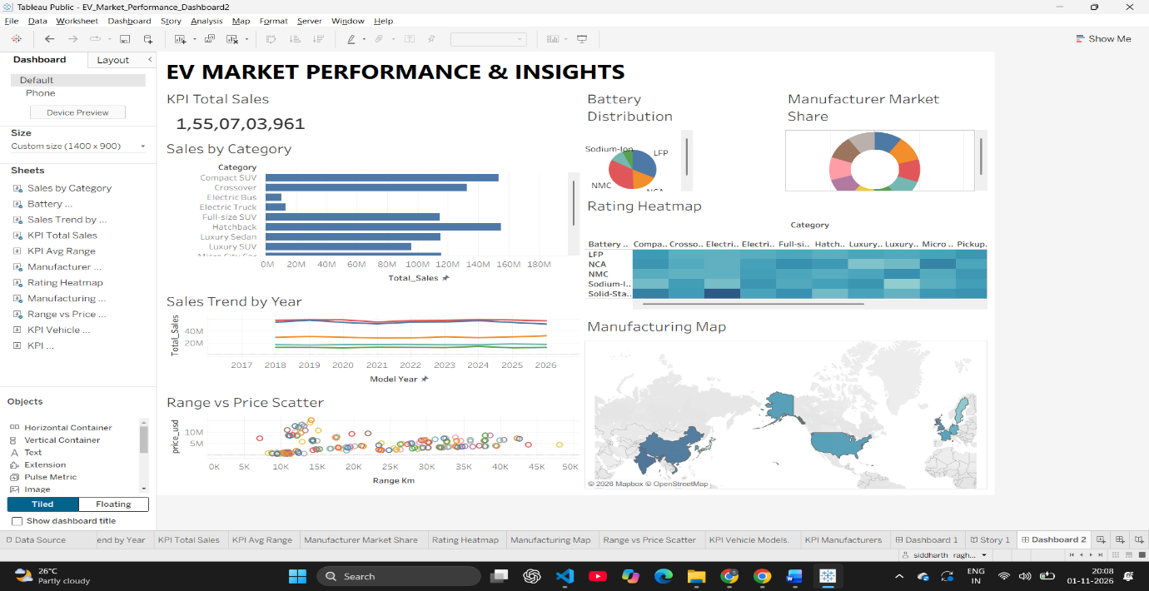
Note: Highlight the major outcomes in form of bullet points
Outcomes from the EV Market Dashboard:
- Total Sales Volume: The dashboard reports a massive total sales KPI of 1,55,07,03,961, indicating the large scale of the global EV market being analyzed.
- Category Dominance: The "Sales by Category" chart clearly shows that Compact SUVs are the top-selling vehicle type, significantly outperforming Hatchbacks and Luxury Sedans.
- Battery Technology Preference: The "Battery Distribution" pie chart reveals that LFP (Lithium Iron Phosphate) and NMC (Nickel Manganese Cobalt) are the dominant battery technologies across most vehicle categories.
- Consistent Market Growth: The "Sales Trend by Year" line chart demonstrates a clear, continuous upward trajectory in global EV sales from 2017 through the projected 2026 timeline.
- Geographic Manufacturing Hubs: The "Manufacturing Map" highlights that EV production is heavily concentrated in specific regions, primarily North America, Europe, and parts of Asia, showing supply chain localization.

Activity 2
Publish Dashboard on Tableau Public and Paste the Dashboard Public link below:
Example
https://public.tableau.com/app/profile/siddharth.raghuwanshi6833/viz/EV_Market_Performance_Dashboard2/Dashboard2?publish=yes

